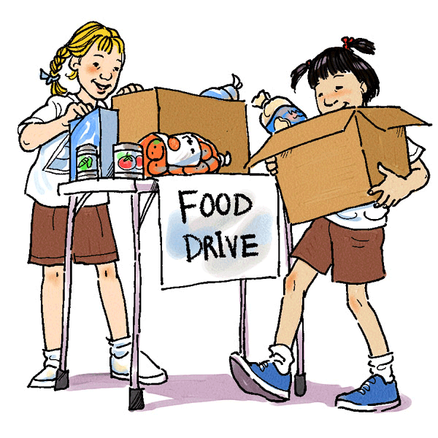
Service Learning
Can one person make a difference? We think so. You have important skills that can have a tremendous impact on someone else’s life. This year you will have the opportunity to help your community in a way that only you can. Through your work, you will not only learn valuable work skills and make new friends, but will also hopefully gain a new appreciation for those in need.
The Basics:
- Each student is required to complete three hours of service learning this school year in fulfillment of S.S.7.C.2.14.
- Before completing your service, you must get approval from your parents, the organization and your teacher. See “Guidelines” for service restrictions.
- All students will complete a reflection project following their work. This will count as a test grade.
- An alternate written project will be available for students unable to complete the service requirement. These students are responsible for getting the details of the assignment from their teacher before the project deadline.
Service Guidelines:
- Work must be done outside of school hours (9:20 – 3:42)
- Your supervisor at the volunteer location must not be related to you
- Participating in a fundraising walk does not count; consider assisting with the walk (i.e. setting up tables, handing out water)
- Remember that even though you may not be on LAJH’s campus, you still represent LAJH. Be positive, well-mannered and respectful at all times.
- Students are welcome to work together to create their own community service project. This must be pre-approved like all other projects.
Due Dates:
August 31st : Parent Consent due
October 3rd: Service Learning Plan and/or letter stating intent to complete alternate project due
January 5th : All projects are due

